SPECIAL CONSTRUCTION PVT. LTD.
Powering Roads — Reliable Machines, Genuine Parts, Responsive Service
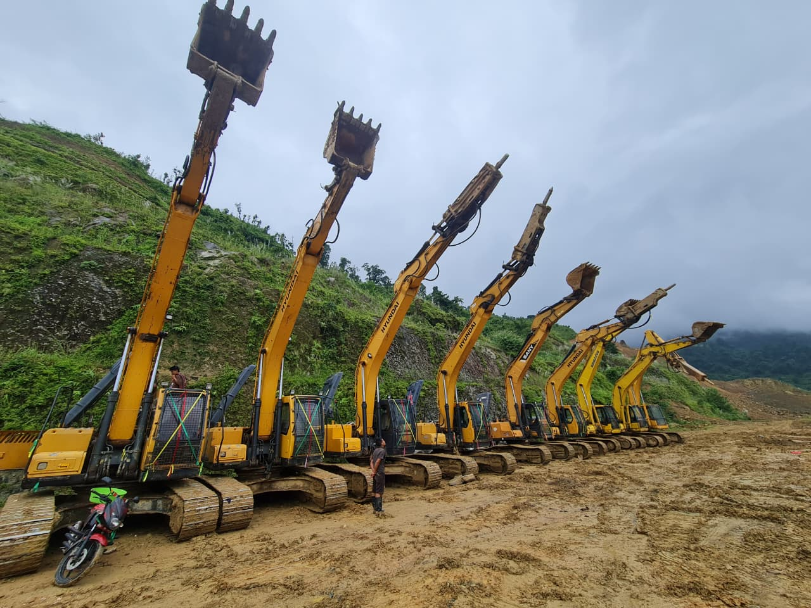
Balkumari-9, Lalitpur, Nepal
Phone: +977-9851098449
Email: shalikco75@gmail.com
Website: https://specialheavy.com/
Established: 2010 A.D.

About Us
Special Construction Pvt. Ltd. is a privately held company established in 2010, based in Balkumari-9, Lalitpur, Nepal. Over the years, the company has expanded its operations, creating two sister companies to cater to specialized sectors: Special Heavy Equipment Works Pvt. Ltd. and Shalik Construction Pvt. Ltd.
The company specializes in construction equipment rental, heavy equipment parts import and sales, and maintenance services for road construction and infrastructure projects across Nepal.
With a strong foundation built on integrity, quality workmanship, and client satisfaction, Special Construction Pvt. Ltd. continues to lead in Nepal’s infrastructure development — from major road and bridge projects to the maintenance of large-scale construction machinery.
Our Sister Companies
1. Special Heavy Equipment Works Pvt. Ltd.
This company focuses on repair, maintenance, and servicing of heavy construction machinery, ensuring that equipment such as:
- Excavators
- Backhoe Loaders
- Rollers
- Wheel Loaders
- Bulldozers
operate at peak performance.
With a dedicated team of skilled mechanics and engineers, the company provides reliable, on-time, and cost-effective maintenance solutions to contractors and construction firms across Nepal.
2. Shalik Construction Pvt. Ltd.
Shalik Construction Pvt. Ltd. specializes in infrastructure construction, handling projects that shape communities and drive progress.
Our areas of expertise include:
- Road and Highway Construction
- Building and Structural Works
- Bridge Construction
- Tunnel Development
With a commitment to innovation and sustainable engineering, Shalik Construction has become a trusted name in Nepal’s construction sector.

Mission
To provide reliable, cost-effective heavy equipment and parts, enabling safer and more efficient road construction across Nepal.
- To deliver high-quality construction and maintenance services on time and within budget.
- To promote sustainable engineering practices.
- To continuously improve through technology, teamwork, and client feedback.

Vision
To be the trusted national partner for road contractors by 2030 — reliable fleet, best-in-class support, and rapid parts availability.
To be a leading construction group in Nepal, recognized for quality, safety, and innovation in both infrastructure development and heavy equipment management.

Core Values
- Integrity: Honesty and transparency in all business dealings.
- Excellence: Commitment to superior performance and continuous improvement.
- Safety: Ensuring a safe work environment for employees and clients.
- Sustainability: Building responsibly for future generations.
- Customer Satisfaction: Exceeding expectations through dedicated service

Core Services
- Heavy Equipment Rental – Excavators, Rollers, Backhoe Loaders, Graders, and other machinery used for road construction.
- Machinery Parts Import & Sales – Genuine and high-quality aftermarket parts for major machinery brands.
- Maintenance & Technical Support – Preventive maintenance, on-site servicing, and parts replacement.
- Fleet Mobilization – Rapid deployment and nationwide delivery of equipment.
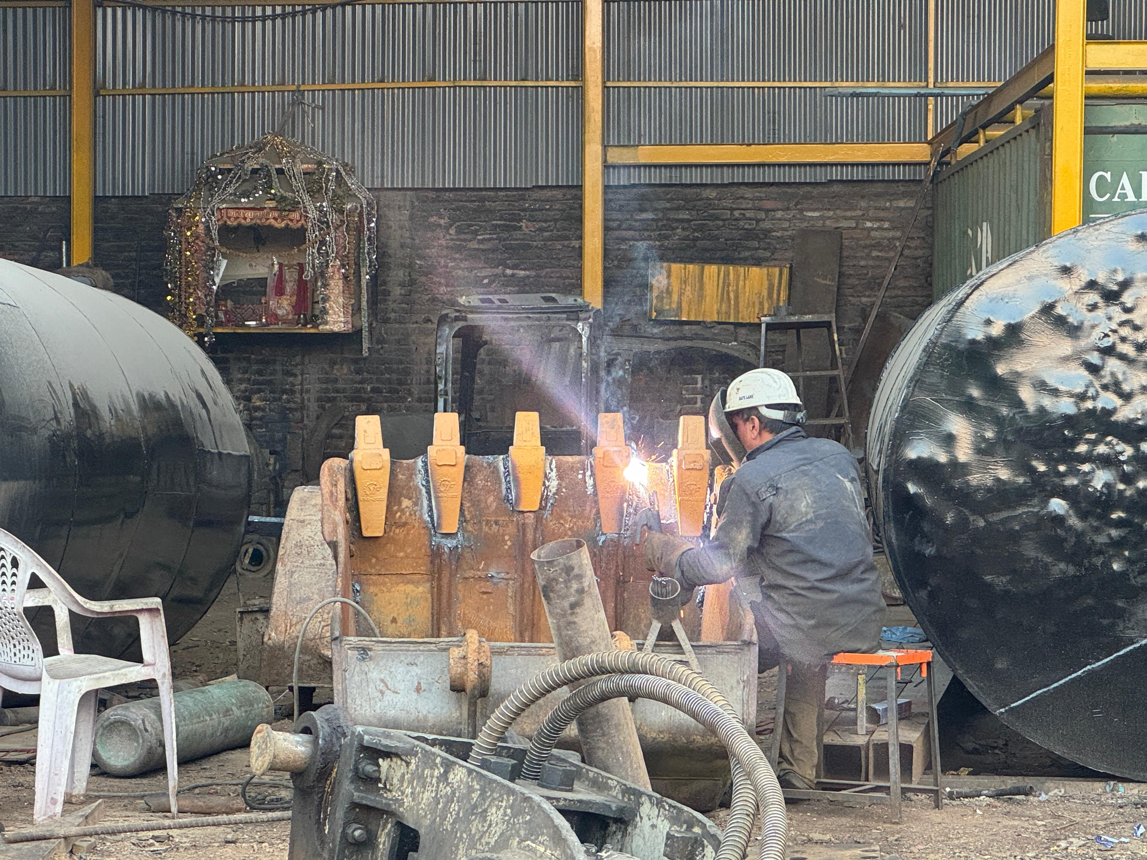

Our Fleet
Our company operates a well-maintained fleet of heavy machinery that supports construction and infrastructure development across Nepal. Below are some of our equipment in operation.
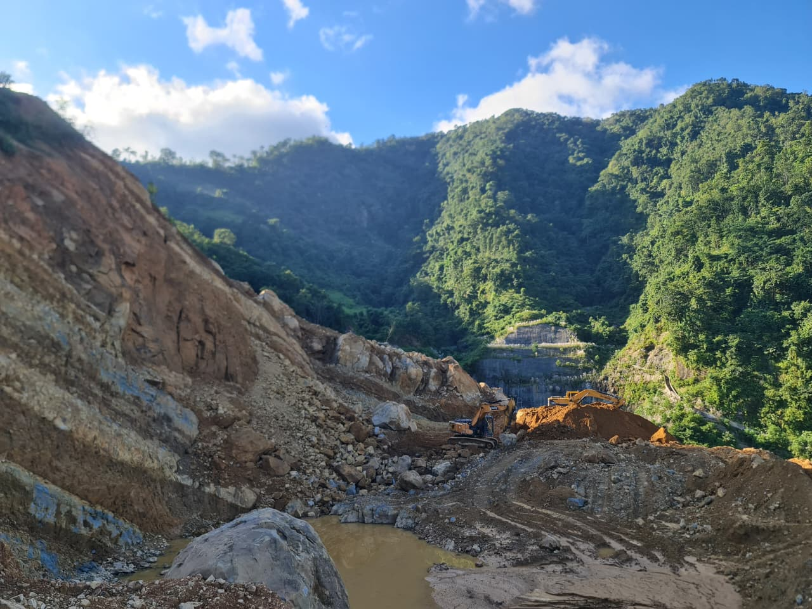
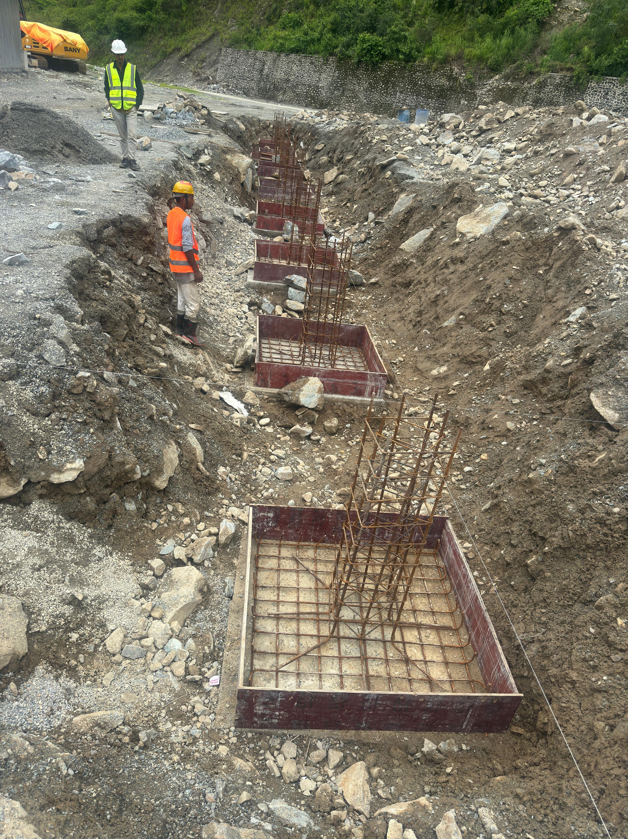

Projects & Operations
Special Construction Pvt. Ltd. has contributed to numerous road and infrastructure development projects throughout Nepal. Our reliable equipment fleet and experienced operators ensure timely and efficient project delivery.

[site Project Photo]
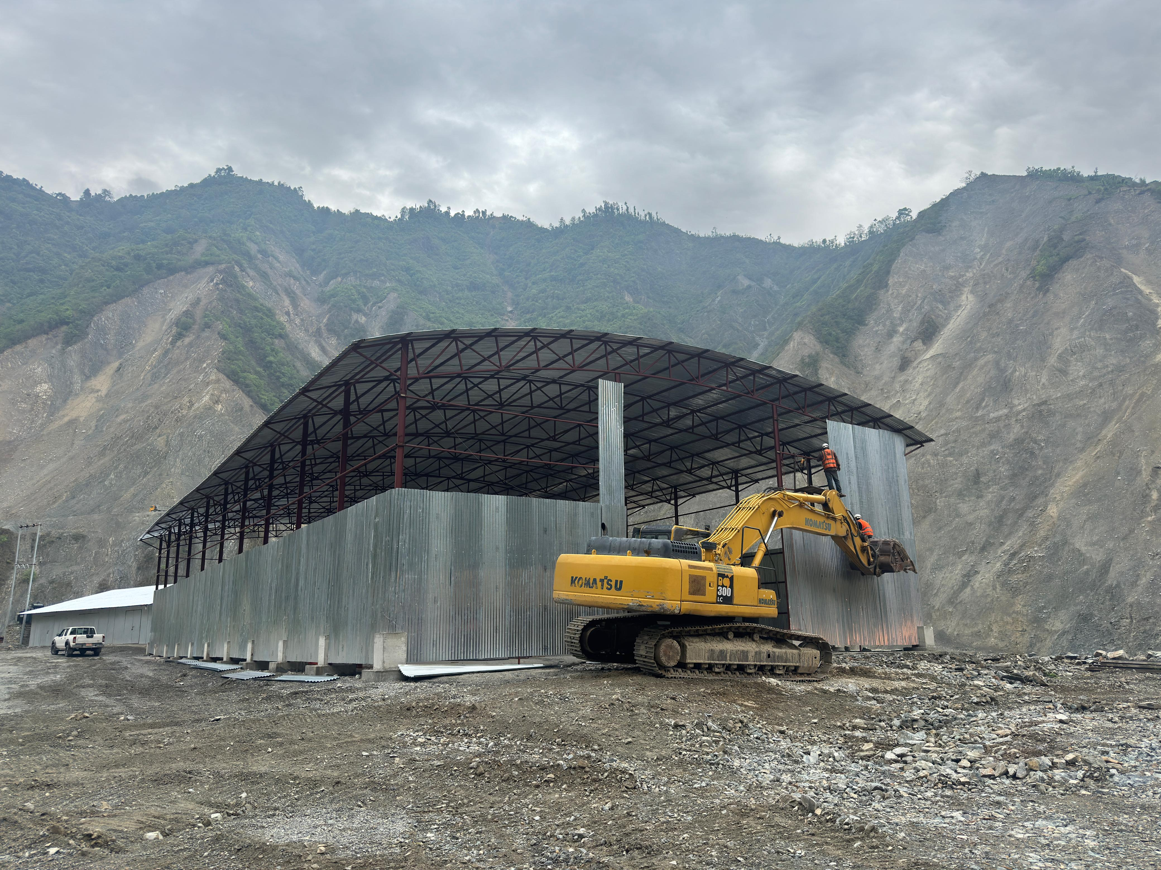

Contact Information
Special Construction Pvt. Ltd.
Balkumari-9, Lalitpur, Nepal
Phone: +977-9851098449
Email: shalikco75@gmail.com
Website: https://specialheavy.com/
Established: 2010 A.D.
Thank you for choosing Special Construction Pvt. Ltd. — your trusted partner in construction and heavy equipment solutions.

